To complete the New Patient Packet, select the link below Patient Forms next to the blue arrow stating ‘New Patient Packet’
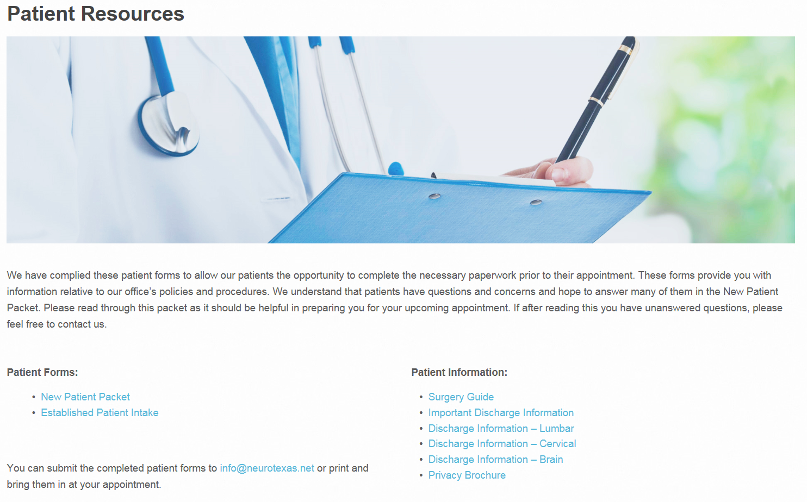
A PDF version should open with the New Patient paperwork. At this time, you can choose to type in your information, save to your computer/files and email as an attachment or you can print this document to handwrite and bring it into our office at the time of your appointment. If you choose to type your information, be sure to save your information before submitting online or printing. In the top left hand corner, above the blue arrow, select File and Save As.
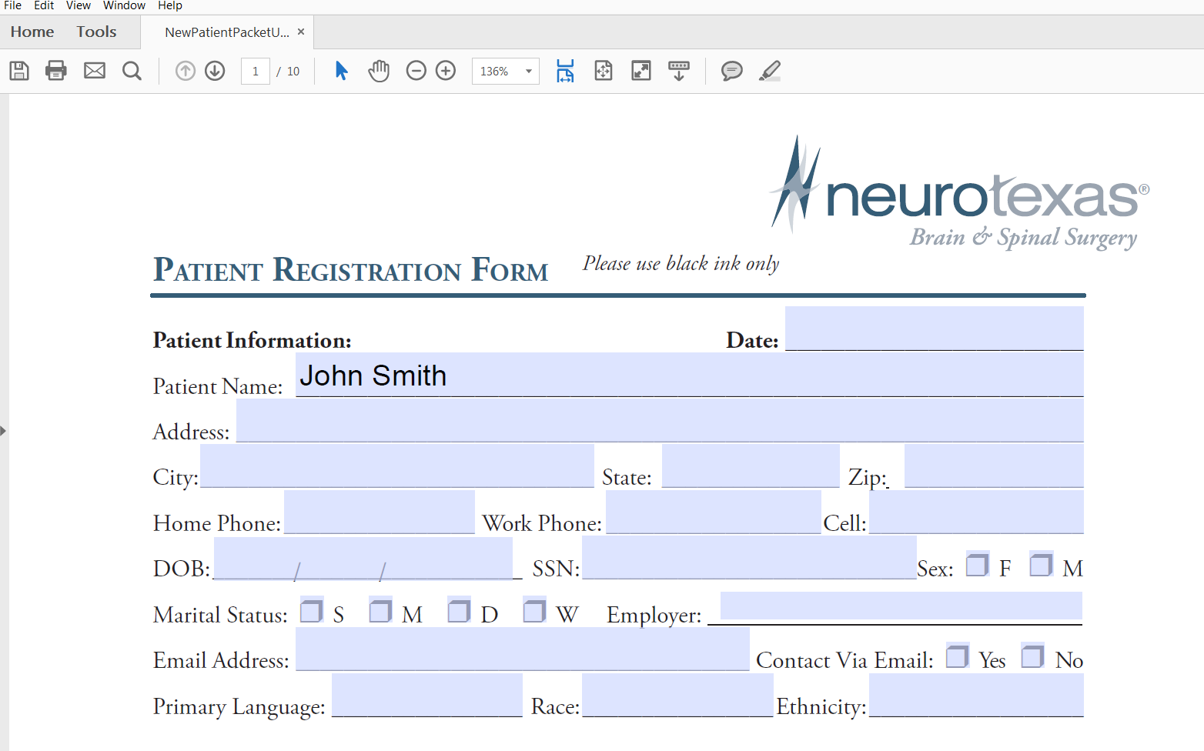
Save the document. We recommend using your name at the document title. If submitting online, please send your New Patient Packet to info@neurotexas.net
